Lab No 10
Lab Title:
Practicing Loops in C++.
Objective:
The main Objective of this lab is to practicing loops in C++.
Task 1:
Write a program which prints factorial of a number in C++.
TOOLS:
A) PC B) Code Blocks
PROCEDURE:
i. First we create new project in Code blocks, Console then named it.
iii. Write the program which is required for our task, then build it.
iv. Compile the program and run it.
CODING:- | 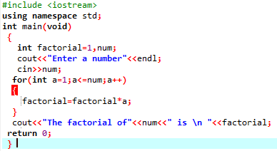
OUTPUT:- | 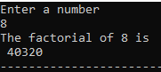
Task 2:
Write a program which prints/displays “*” and in every line “*” increases.
PROCEDURE:
i. First we create new project in Code blocks and Jupyter Notebook, Console then named it.
iii. Write the program which is required for our task, then build it.
iv. Compile the program and run it.
CODING:- | 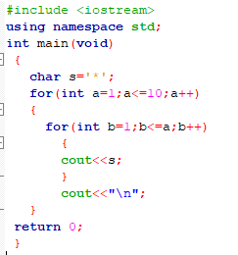
OUTPUT:- | 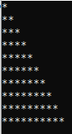
Conclusion:
We are familiar about how to use loops in C++.

